Resource sheet
Human rights images
The following images are a visual representation of various human rights. Some images may be associated with more than one right. Key rights that may be associated with images are equality, right to vote, nationality, identity, freedom from persecution, labour rights, freedom of speech, leisure, participation, education, shelter.
Pictures cards can be copied for educational purposes and cut as cards for distribution. Photo images are by Amanda Lim (2003 Human Rights Photography Competition), cartoon images are from Shutterstock Photos (http://www.shutterstock.com) and drawings are by Adam Hill
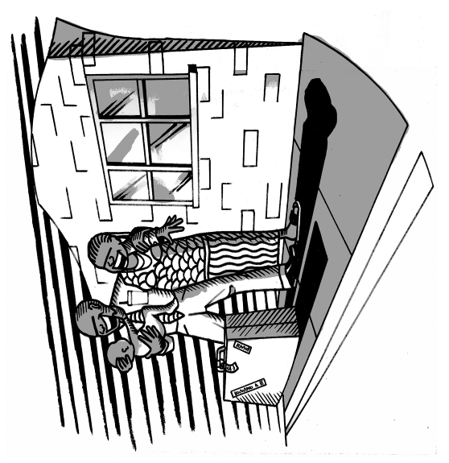 | 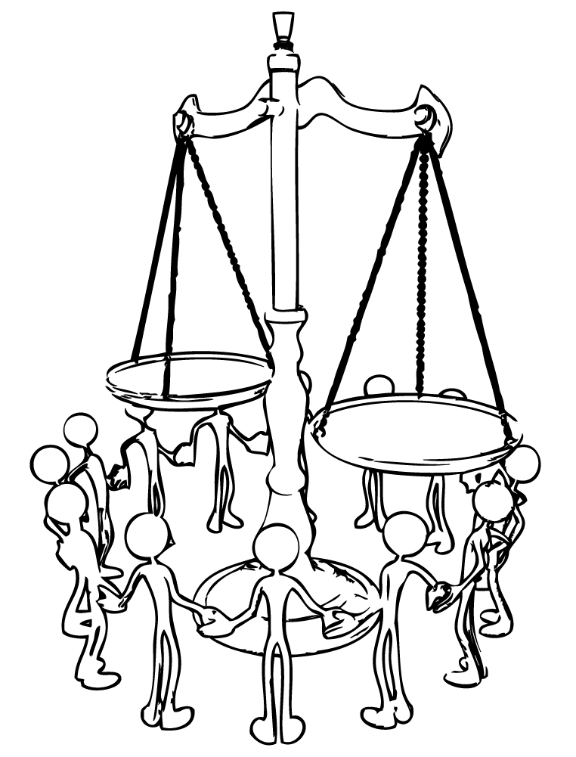
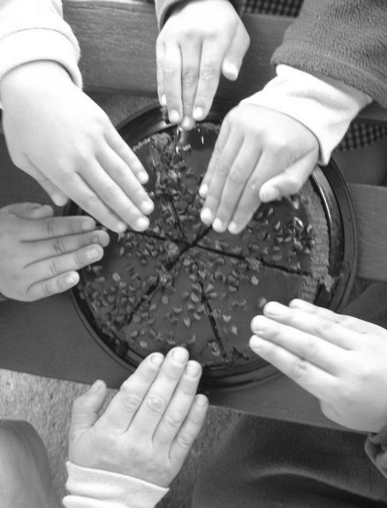 | 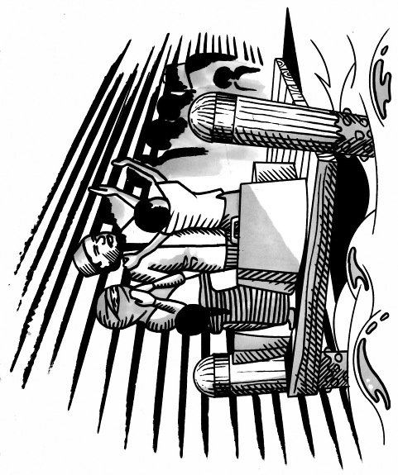

Resource sheet
Human rights images
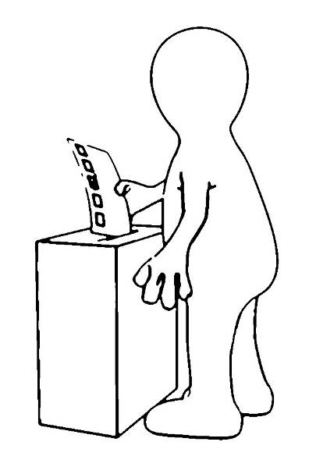 | 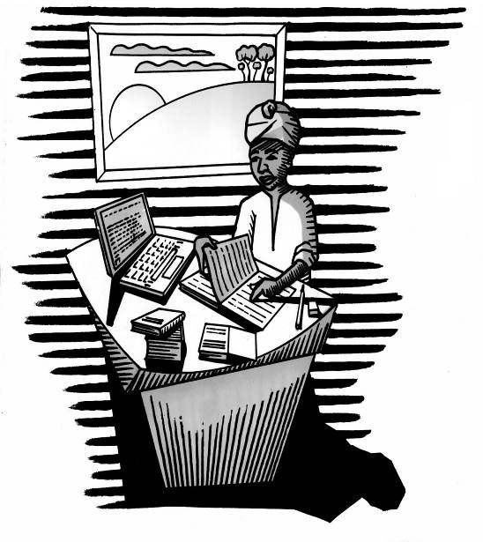
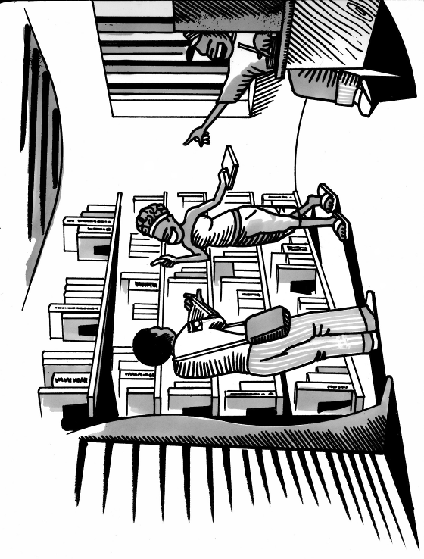 | 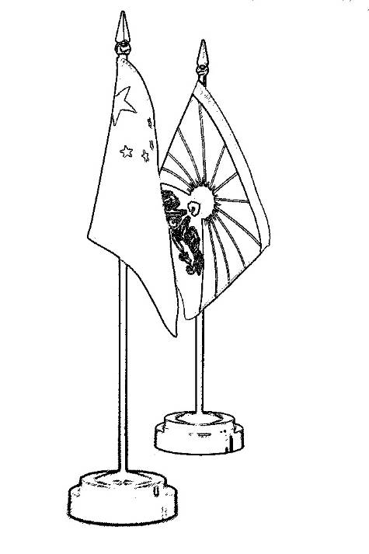

Resource sheet
Human rights images
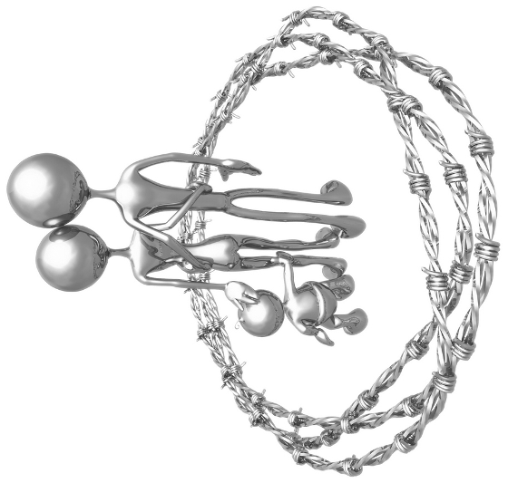 | 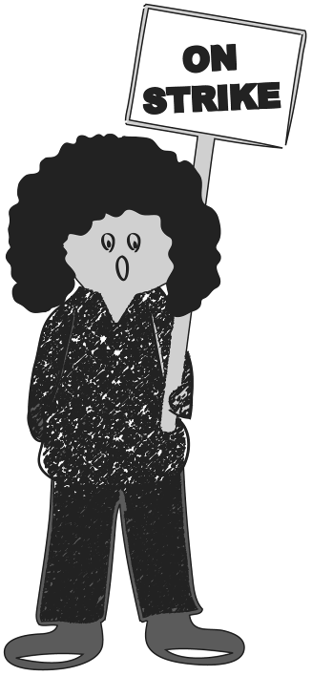
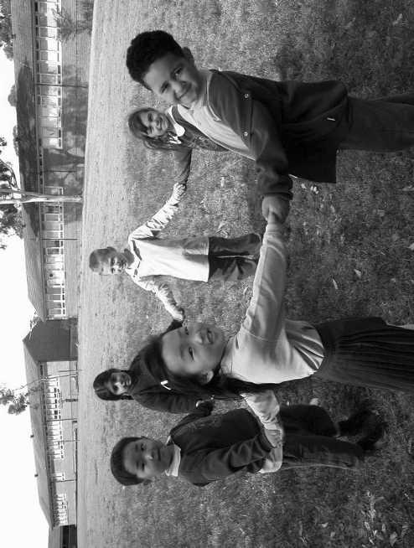 | 